**Project Title**: IoT based Posture Monitoring Device for Abnormal Spine Musculoskeletal Detection Using Flex Sensor

**BME 3200: Biomedical Systems Design Project**

*A project submitted to the Department of Biomedical Engineering in Third Year Second Semester*

**

**Supervised by Submitted by**

Name: Dr. Md. Bashir Uddin Name: Suraiya Binta Zaman

Designation: Associate Professor Roll: 1915009 Dpt. : Biomedical Engineering

Dpt. : Biomedical Engineering

Department of Biomedical Engineering Khulna University of Engineering & Technology

Khulna-9203, Bangladesh December 2023

## ABSTRACT

During activity of daily living involving standing, sitting or maneuvering, humans are typically susceptible to neck and shoulder strain, and other musculoskeletal conditions, severity of which may lead to posture deformity. To prevent these clinical conditions, I develop a low-cost and user- friendly posture monitor mainly built on a single flex sensor. The design was based on abnormal posture detection by a flex sensor whose signal triggers a buzzer to notify the user or care giver of these clinical conditions. Through Arduino IDE, microcontroller controlled the sequence of the flex sensing to the audible alarm output. The buzzer was designed to go off automatically when the user adjusts his/her posture to normalcy. With a sensitivity of 68.83% during testing of this device, the developed posture monitoring device could be adjudged effective and suitable to monitor people's posture while sitting or standing especially in environments where menial jobs are prevalent. In these individuals, this device may prevent deformity prone diseases that may warrant surgical intervention for correction. Posture monitoring aiming at preventing many of the pathologies affecting the spine is becoming more and more essential in many contexts, including telemedicine. The market pushes towards the development of new technical solutions that are comfortable for the user and that are increasingly becoming lower in terms of cost. Here, I report on the development, at a prototype level, a simple, low-cost, and potentially very comfortable microcontroller-based system capable of signaling incorrect postures with great sensitivity. Experimental activity has proven the prototype’s functionality. The wearable embedded system is able to detect flections in the back region monitored by the flex sensor with a maximum accuracy. The achievement represents a further demonstration of the potential of wearable electronics in the context of cyber-physical systems for healthcare. Moreover here I use a Bluetooth module to send the sensor information to the user’s mobile phone in order to control the system easily. I have used a in built mobile app to show the data. The system performance revealed the relationship between flex sensor and image analysis measurements.

**List of Abbreviations & Symbols**

|  |  |
| --- | --- |
| wt % | Weight Percent |
| °C | Degree Celsius |
| MJ/kg | Mega joule per Kilogram |
| Kg/m3 | Kilogram per cubic meter |
| KgOE | Kilogram of Oil Equivalent |
| GCV | Gross Calorific value |
| SBR | Styrene Butadiene Rubber |
| BR | Butadiene Rubber |
| IR | Isoprene Rubber |
| HDPE | High Density Poly Ethylene |
| LDPE | Low Density Poly Ethylene |
| PP | Poly Propylene |
| PVC | Poly Vinyl Choloride |
| PET | Poly Ethelene Terapthalate |
| PS | Poly Styrene |
| EPT | Ethylene Propylene Terpolymer |
| IIR | Isobutylene Iso-prene Rubber |
| UV | Ultraviolet |
| NR | Natural Rubber |
| PBR | Polybutadiene Rubber |
| EPA | European Pollution Authority |
| MJ | Mega Joule |
| FCC | Fluid Catalytic Craking |
| TGA | Thermo Gravimetric Analysis |
| KW | Kilowatt |
| N2 | Nitrogen Gas |
| CT ratio | Catalyst -Tyre ratio |
| ASTM | American Society for Testing Materials |
| FTIR | Fourier Transform Infra –Red |
| CARS | Centre for Advanced Research in Sciences |
| TCR | Total Capital Requirement |
| FCI | Fixed Capital Investment. |
| O-H | Hydroxyl stretching |
| N-H | Amines |
| C-H | Carbon Hydrogen (Alkanes group) |
| C=C | Carbon Hydrogen double bonding |
| C-O | Carbonyl Stretching |
| O-H | Alcohol, Phenol group |
| C≡C | Carbon Hydrogen Triple Bonding (Alkynes) |

**Table of Contents**

|  |  |
| --- | --- |
|  | **Page** |
| Title Page | i |
| Abstract | ii |
| List of Abbreviations & Symbols | iii |
| Table of Contents | iv |
| Index | v |
| List of Tables | vi |
| List of Figures | vii -viii |
| List of Illustrations | ix |



**Index**

|  |  |  |
| --- | --- | --- |
|  |  | page |
| **CHAPTER 1** | **Introduction** |  |
|  | 1.1 General | 1-3 |
|  | 1.2 Scope of present Investigation | 3-4 |
|  | 1.3 Some pictures of posture detection circuit | 5-6 |
|  |  |  |
| **CHAPTER 2** | **Motivation/ Background Study** |  |
|  | 2.1: History behind this project | 7-8 |
|  | 2.2: Significant in health and well being | 8-9 |
|  | 2.3: important in Athletic performance measurement | 9-10 |
|  | 2.4: Significance in ergonomics | 11 |
|  | 2.5: Some others motivation behind this device | 12 |
|  | 2.6: IOT based application | 12 |
|  | 2.6.1: Real time monitoring and Remote accessibility | 13 |
|  | 2.6.2: Cloud based storage and alerts and notification. | 13 |
|  | 2.6.3: Research and population health |  |
|  |  |  |
| **CHAPTER 3** | **Methodology** | 14 |
|  | 3.1: System design and description | 14 |
|  | 3.2: Theoretical background/ Design specification | 15-16 |
|  | 3.3: Operational Algorithm | 16 |
|  |  |  |
|  |  |  |
| **CHAPTER 4** | **Design procedure/Experimental set-up/ Circuit Diagram** | 17 |
|  | 4.1 Introduction | 17-18 |
|  | 4.1.1: Cost analysis | 18-19 |
|  | 4.2 Materials and methods | 19-24 |
|  | 4.3 Experimental Set-up | 25 |
| 4.4 Experimental Procedure | 25-26 |
|  |  |
|  |  |  |
| C**HAPTER 5** | **Implementation (Step by Steps with pictorial view)** | 27 |
|  | 5.1: Breadboard implementation | 27 |
|  | 5.2: PCB connection | 28-30 |
|  | 5.3: Total posture monitoring device including IOT | 31 |
|  |  |  |
| **CHAPTER 6** | **Results and Discussions** | 32 |
|  | 6.1 Threshold value calculation | 32 |
|  | 6.1.1: Sensitivity Calculation | 33-35 |
|  | 6.2 Discussions | 35-36 |
|  |  |  |
| **CHAPTER 7** | **Conclusion and Future Work** | 36 |
|  | 7.1 Conclusion | 36 |
|  | 7.2 Future Work | 37 |
|  |  |  |
|  | **References** | 38-40 |
|  | **Appendix** | 40 |

**LIST OF TABLES**

|  |  |  |
| --- | --- | --- |
| **Table No.** | **Description** | **Page** |
|  |  |  |
| 4.1 | Material selection and justifications | 17-18 |
| 4.2 | Cost analysis of required materials | 18 |
| 6.1 | Threshold values and at which threshold value for each person the buzzer is on. | 32 |
| 6.2 | Determine the sensitivity of my Posture Monitoring Device. | 35 |

**LIST OF FIGURES**

|  |  |  |
| --- | --- | --- |
| **Figure No** | **Description** | **Page** |
| 1.1 | Correct and Incorrect posture position | 2 |
| 1.2 | A schematic diagram of flex sensor connection | 3 |
| 1.3 | Arduino, flex sensor and Bluetooth connection for my posture monitoring system. | 5 |
| 1.4 | Bend of flex sensor and as a result Red LED in on. | 6 |
| 1.5 | Breadboard connection of my IOT based posture monitoring device. | 6 |
| 3.2 | Equivalent circuit model for Resistive flex sensor | 5 |
| 3.3 | Flex sensor voltage divider configuration for this design. | 16 |
| 4.1 | A picture of Breadboard. | 19 |
| 4.2 | A picture of Flex sensor | 20 |
| 4.3 | A picture of Arduino nano | 20 |
| 4.4 | A picture of H05 Bluetooth module | 21 |
| 4.5 | A picture of a buzzer and a vibrator. | 21 |
| 4.6 | A picture of a resistor | 22 |
| 4.7 | A picture of a LED light | 22 |
| 4.8 | A picture of a rechargeable battery | 23 |
| 4.9 | A picture of a PCB board. | 23 |
| 4.10 | A picture of a voltage regulator. | 24 |
| 4.11 | Posture correction belt. | 24 |
| 4.12 | Total experimental setup of posture monitoring device. | 25 |

|  |  |  |
| --- | --- | --- |
| 5.1 | Here Arduino, 160 k resistor and LED are attached. Also a Bluetooth module is attached to send the data into mobile application. | 27 |
| 5.2 | Here the main flex sensor is attached. And the circuit is completed. | 27 |
| 5.3 | The main designed circuit of my PCB board | 28 |
| 5.4 | Here the back portion of my PCB board after printing. | 28 |
| 5.5 | Here after connecting the interconnection of components in PCB board | 28 |
| 5.6 | After completing soldering, it is the picture of back portion of my PCB board. | 29 |
| 5.7 | Attaching LEDs, resistor and buzzer on my PCB board | 29 |
| 5.8 | After connecting my Arduino Nano on my PCB board | 29 |
| 5.9 | After connecting Bluetooth module on my PCB board | 30 |
| 5.10 | After connecting two rechargeable batteries on my PCB board | 30 |
| 5.11 | After attaching flex sensor to my PCB board and here is a also a vibration motor. | 30 |
| 5.12 | Here is an attachable posture correction belt for attaching flex sensor. | 31 |
| 5.13 | Iot based posture monitoring device | 31 |

viii

## LIST OF ILLUSTRATIONS

|  |  |  |
| --- | --- | --- |
| **Figure No** | **Description** | **Page** |
|  |  |  |
| 1.1 | Flowchart of working of my IOT based posture monitoring system. | 5 |
| 3.1 | Block diagram of methodology of wearable posture monitoring device. | 14 |

**DEDICATED TO My**

**Parents**

# Chapter 1

## Introduction

* 1. **: General**

Sitting is the most common status of modern human beings and poor postures may affect head/neck posture and cervicothoracic muscle activity [1], bring health problems, especially for young students [2]. For example, keeping a neutral lumbar position is very important for health. However, the habitual sitting posture causes more flexed lower lumbar spine [3], which may increase health risks. According to a survey [4], people are sitting on an average of 13 hours a day. However,

a long period of sitting may increase risk of obesity and metabolic diseases [5]. With bad postures, it may bring more health problems like postural pain [1]. Besides, improper sitting postures with a long period sedentary life may increase the risk of hyperflexion injury [6], and may cause musculoskeletal disorders such as back pain with deteriorating lung function [7], low back pain or injury [8], pains in muscle and connective tissues of tendons [9], increasing spine load [10], changing cervical spine position [11], neck pain [12], pressure ulcers in some patients [13] and shoulder pain [14].

For the above-mentioned long-time sitting caused heart disease problems, wearable sensors [15],

[16] were proposed to monitor the status of the heart. The warning systems were created to prevent delayed treatment, such as the wireless transceivers [17], the integrated Ultra-wideband (UWB) communication system [18], [19] using On-off Keying (OOK) and Frequency-shift Keying (FSK), and the system [20] with Delta-sigma encoder. Though, those solutions may help people avoid serious conditions, considering user experience, privacy, reliability, and hardware resource overhead, a low-power local implemented real-time monitoring system for directly sitting posture recognition is expected.

According to the world health organization (WHO), musculoskeletal illnesses are mostly responsible for physical disability globally irrespective of age [1]. This illness is characterized by shoulder, back and neck pains and may significantly affect physical and functional activities, and ultimately threatens useful productive life and healthy living [2, 3]. For example, slouching which

may negatively affect the “transverses abdominis muscle” may lead to low back pain [4, 5]. Also shoulder and low back pains are common in workplaces where workstations are used [6] leading to “Work-Related Musculoskeletal Disorder” [7].

The objective of this project is to develop a relatively in- expensive, comfortable and user-friendly system to monitor sitting posture in real-time. An elementary portable device connected to a smartphone via bluetooth using a flex sensor is represented. The user has to set the range in which he feels comfortable and receives a vibration in the motor when the angle crosses the safe range of good posture.

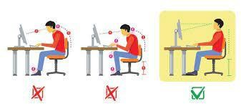

Figure 1.1: Correct and Incorrect posture position

Proper sitting posture refers to the position in which natural spinal curvature and arm, shoulder, hip, and knee position are properly maintained and aligned. Incorrect posture gradually decreases the flexibility of the spine causing pain in neck, shoulder and back. Furthermore, incorrect sitting posture has detrimental effects on digestion and respiration. Back pain is recognized as a common health issue and 75-85% of adults deal with back pain at least once in their lifetime [1]. In 2016, low back pain and neck pain combinedly were the 4*th* leading cause of disability-adjusted life year (DALY) globally [2]. ]. The World Health Organization (WHO) reported that 9.5 million people in South-East Asia were affected by back and neck pain. Lack of knowledge of correct posture is assumed to be the primary cause of backache, yet a study that 60.8% of physiotherapists in Bangladesh have low back pain [4]. A cross-sectional study on Ready-Made Garment employees (RMG) of Bangladesh have reported 24.7% of female worker respondents had lower back pain and 23.% of female worker respondents had neck pain [5]. As many people spend most of the

time sitting down in the workplace or home, bad alignment of sitting causes several problems such as bad support on muscles, ligaments, tendons and unhealthy spine [6].

There are several treatment methods for these abnormalities and depending on the severity, doctor advices to stay active and/or bed rest, prescribe medication [7], physical therapies [8], exercises [9], surgery [10], spinal traction therapy [11] etc. On the other hand, as a proactive practice, good sitting posture improves the body’s circulatory and digestive system, increases self-confidence, decreases the risk of abnormal wear- ing of the joint surfaces, improves core and scapular strength etc [12]. Therefore, it is an excellent decision to make a habit of good sitting posture by monitoring as it brings many benefits for the human body without any unnecessary side- effects. There has been a lot of effort to prevent back pain using eTextile sensor [13] and flex sensor to monitor sitting posture based ergonomic design. Moreover, there are some approaches based on machine learning and accelerometers [14] [15]. Most of these are very useful but complex, difficult to operate and very expensive.

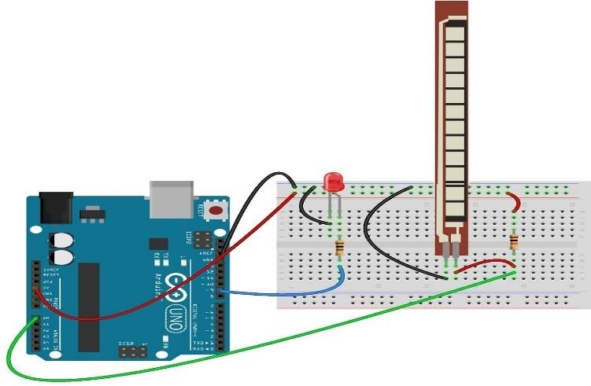

Figure 1.2: A schematic diagram of flex sensor connection

## : Scope of present investigation:

In the area of IOT based wearable posture monitoring devices there are some scope of present investigation:

* + 1. We may explore the technical architecture of posture monitoring device including different type of sensors, hardware and data storage.
    2. We may also investigate how data are collected , processed and stored by the device.
    3. We can examine the methods of connectivity of Wi-Fi, Bluetooth module and other communication protocol to evaluate their efficiency.
    4. In the field of health science we may do research on the benefit of health impact of the device.
    5. On the purposes of preventing back pain and musculoskeletal disorder its effectiveness must be measured.
    6. we can evaluate the user interface of the associated application or displays that usre’s interact with it.
    7. Explores how the device provide feedback to user about their posture and how the feedback can be customized depends of the user’s need.
    8. Investigate the security measure in place to protect the data of different persons by the device. This includes encryption, data storage, and secure communication protocol.
    9. We have to investigate the address potential privacy issues related to the collection and storage of personal health data.
    10. We may assess the scalability of the system and also considering to handle a large number of users simultaneously.
    11. We may investigate the long term impact of using posture monitoring device in case of different section.
    12. There is also investigation scope of the compatibility of the device with various devices and operating system.

The present scope of investigation should consider a multidisciplinary approach involving experts in fields such as medicine, engineering, computer science, human-computer interaction and business to ensure a comprehensive understanding of the device’s scope and potential impact.

## : Some pictures of my project:

Here are some pictures of my project:

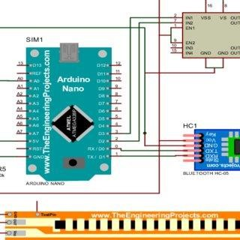

Figure 1.3: Arduino, flex sensor and Bluetooth connection for my posture monitoring system.

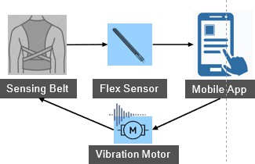

Flowchart 1.1: Working of my IOT based posture monitoring system.

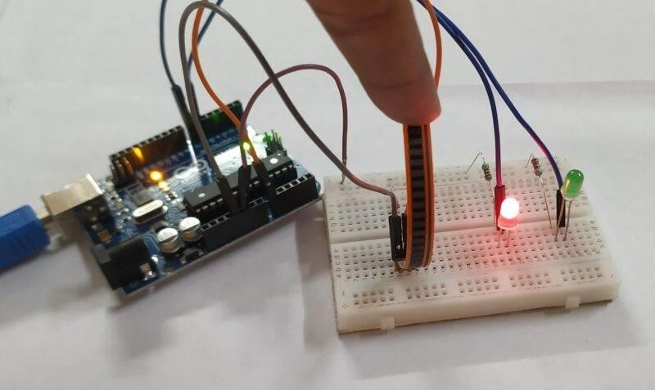

Figure 1.4: Bend of flex sensor and as a result Red LED in on

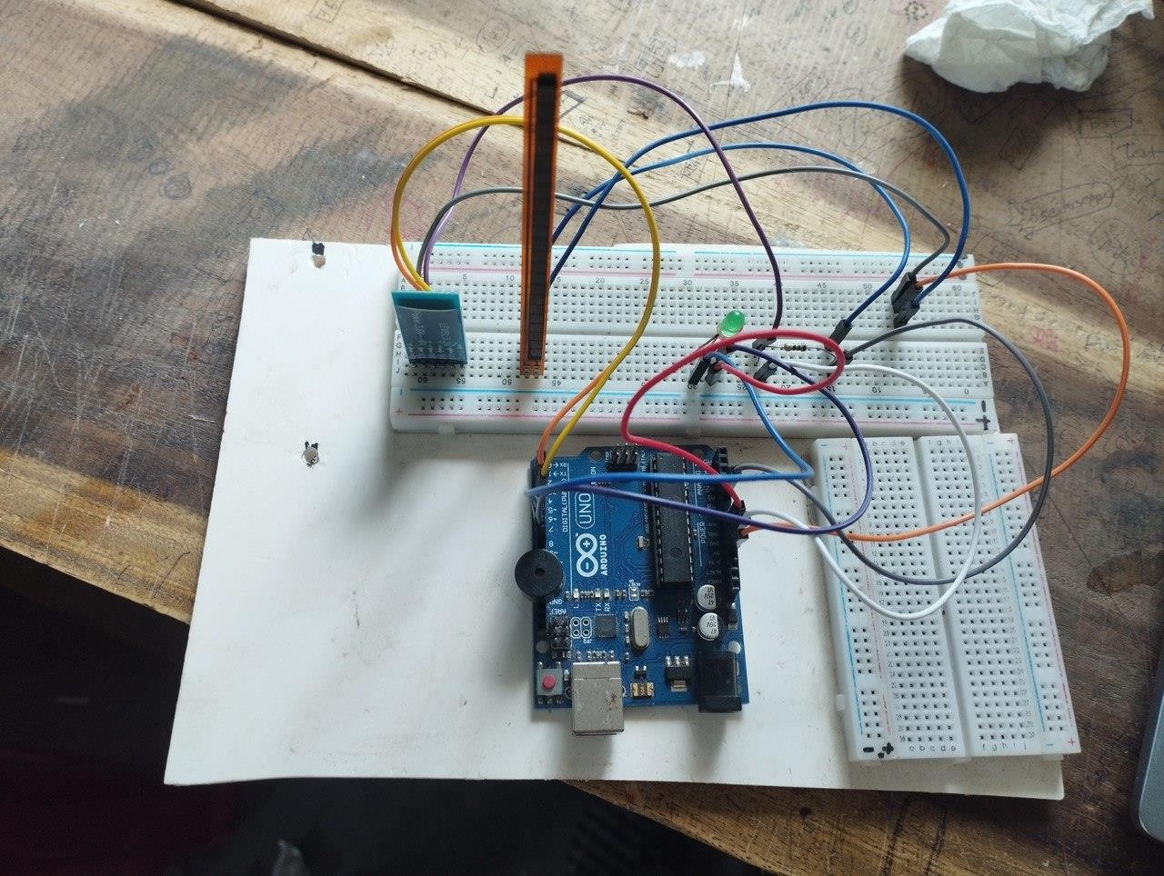

Figure 1.5: Breadboard connection of my IOT based posture monitoring device.

# Chapter 2

## Motivation and background study

* 1. **: History behind this project:**

New technologies and fields of applications of these technologies are rapidly developing, and this development has promptly taken place in our lives in parallel to these technologies. Some of these technologies is low-cost development cards and low-cost sensors that can be integrated and used together. These cards and sensors help to develop prototype products that can be used in various application areas. This is also the case for wearable electronic technology.

Saggio *et al.* (2014) found statistically the relation between the hand holding positions and the measurements of elasticity sensor. They found the pearson correlation coefficient as 0.98 of this relation. As an example of this, Öz and Alayunt (2011) stated that the work in the field of livestock has been mechanized and the physical loads of the workers have been reduced. Despite this fact, they have now defined livestock as an area that contains stresses from the ergonomic point of view, especially with musculoskeletal diseases. They stated that this situation originated from wrong working positions. Enez and Nalbantoğlu (2015) used the REBA method for regarding wrong activities in forestry and reached to the result that the production work in forestry is “moderate.”

Karaçizmeli *et al.* (2014) used a flex sensor placed on a glove for a mechatronic-based robotic hand control. The angular values of the fingers are sensed and processed by a microcontroller, and they used this data for control of servo motors and robotic hand controls. In their work, they

saw that a robotic hand could imitate the movement of a human hand put on a glove. This proves that the robotic hand can be used in contactless and remote environments that can be harmful to humans in a variety of environments.

Korkmaz *et al.* (2016) designed a robot arm that mimics the movements of the fingers according to received signals. Using a 3D printer, a flexible hand glove model was developed by them, flexible glove placed on an ordinary glove, this developed system turns motions into electrical signals and this developed system give chance for different servo motor systems work together.

Tripathi and Pandey (2011) worked on impact of drudgery reducing technology on ergonomics of rural women engaged in milking of animals. They refer the correct posture degree affect the heart rate of rural women engaged in milking of animals.

OWAS, REBA, etc. posture assessment studies are based on observation measures. In this study, an electronic measurement system was used for this aim. Also in this study, considering the developments and price decreases in sensor technology, it is aimed to provide a safety monitoring system which gives an audible warning by measuring the posture angle which can be formed on some threshold value, which can be selected during agricultural works.

## : For health and well-being:

Posture monitoring for health and well-being is an important application of technology aimed at promoting good posture habits and preventing posture-related health issues. Here's how posture monitoring can contribute to health and well-being:

**Awareness**: Posture monitoring systems, often using wearable devices or sensors, provide real- time feedback to individuals about their posture. This awareness is the first step in making positive changes. Users can learn to recognize and correct poor posture habits.

**Preventing Musculoskeletal Disorders:** Maintaining proper posture is critical for preventing musculoskeletal disorders. Poor posture can lead to back pain, neck pain, headaches, and other physical discomfort. Posture monitoring helps users identify and correct harmful habits before they lead to chronic issues.

**Reducing Pain:** For individuals who already suffer from posture-related pain, monitoring systems can be invaluable. They can provide gentle reminders and feedback to help alleviate discomfort by adopting healthier postures.

**Enhancing Breathing:** Good posture improves lung capacity and the efficiency of the respiratory system. Posture monitoring can help users breathe more easily, which is particularly important for those with respiratory conditions.

**Boosting Confidence:** Good posture can boost self-confidence and self-esteem. People who stand and sit tall are often perceived as more confident and assertive. Monitoring and correcting posture can contribute to a positive self-image**.**

**Enhancing Digestion:** Proper posture can improve digestion and reduce discomfort after eating. Slouching can compress the abdomen and affect the digestive process negatively, while good posture promotes healthy digestion.

**Better Sleep:** Maintaining good posture during the day can have positive effects on nighttime sleep. Proper alignment of the spine can help alleviate sleep-related discomfort and may reduce the incidence of sleep disturbances.

**Increased Energy and Productivity:** Maintaining good posture can lead to increased energy levels and productivity. When the body is properly aligned, it is more efficient, and individuals often feel more alert and capable of taking on tasks.

**Fall Prevention**: In the elderly population, poor posture can contribute to an increased risk of falls. Monitoring and correcting posture can help reduce the chances of falling, thus promoting safety and well-being.

**Behavioral Change:** Posture monitoring systems can be designed to provide positive reinforcement, such as reminders, rewards, or gamification. This can encourage users to make lasting changes in their posture habits.

**Data Tracking and Analysis:** Posture monitoring can generate data that can be used to track progress and identify trends in an individual's posture habits. This data can be helpful for healthcare providers, researchers, and individuals seeking to improve their posture.

Overall, posture monitoring for health and well-being empowers individuals to take control of their posture and, in turn, their overall health. By promoting proper posture habits and raising awareness about the importance of good posture, these systems can contribute to a healthier and more comfortable lifestyle.

## : For Athletic performance:

The importance of posture monitoring devices for athletes can't be overstated, as these devices offer a range of benefits that directly impact an athlete's performance, safety, and overall well- being:

**Injury Prevention:** Proper posture is essential for avoiding sports-related injuries. Posture monitoring devices can alert athletes to poor posture and risky movements, helping them correct

9

these issues before they lead to injuries. This is particularly crucial in contact sports and activities with a high risk of injury.

**Performance Optimization:** Maintaining good posture is vital for maximizing athletic performance. Proper alignment and posture can lead to increased power, speed, accuracy, and overall effectiveness in various sports and activities.

**Technique Improvement:** Posture monitoring devices provide athletes with real-time feedback on their body mechanics and posture. This feedback can help athletes fine-tune their technique and form, leading to improved performance and precision.

**Biomechanical Insights:** These devices offer valuable biomechanical insights into an athlete's movements. Athletes and coaches can use this data to analyze and understand the mechanics of each movement, optimizing it for enhanced performance.

**Customized Training:** Posture monitoring devices allow for customized training and adjustments based on the specific needs of each athlete. Athletes can set parameters and thresholds that are tailored to their sport and training goals.

**Consistency:** Athletes can use posture monitoring to ensure consistency in their movements and techniques. Consistency is key in sports, as it helps athletes perform at their best during practices and competitions.

**Coaching and Feedback:** Coaches can remotely monitor an athlete's posture and provide real- time feedback and guidance. This can be especially valuable for remote coaching or for athletes traveling or training in different locations.

**Awareness**: Posture monitoring devices raise awareness of an athlete's posture habits, promoting mindfulness and the development of good posture as a natural part of their training routine.

**Psychological Benefits:** Maintaining good posture can boost an athlete's self-confidence, mental focus, and assertiveness, contributing to better sports performance.

**Long-Term Health:** In addition to athletic performance, good posture supports an athlete's long- term health and well-being by reducing the risk of posture-related health issues, such as back and neck pain.

**Overall Comfort:** Good posture leads to increased comfort and reduces discomfort, fatigue, and stress during and after sports activities.

## : Significance in ergonomics:

Posture monitoring devices are highly significant for ergonomics, as they play a crucial role in promoting and maintaining optimal ergonomic conditions in various environments, including the workplace. Here's why posture monitoring devices are important for ergonomics:

**Posture Awareness:** Posture monitoring devices raise awareness about proper posture and ergonomics among individuals. They provide real-time feedback to users, helping them recognize and correct poor posture habits that can lead to discomfort and musculoskeletal issues.

**Injury Prevention:** Maintaining good posture is fundamental to preventing ergonomic-related injuries, such as repetitive strain injuries (RSIs), back pain, and neck pain. Posture monitoring devices can alert individuals to unfavorable postures and behaviors that may lead to these injuries. **Health and Comfort:** Good ergonomic posture promotes physical comfort, reducing discomfort, fatigue, and strain, especially during long periods of sitting or standing at a workstation. This contributes to better overall health and well-being.

**Workplace Safety:** Good ergonomics reduce the risk of accidents and injuries in the workplace. By monitoring posture, employers can identify and address potential ergonomic hazards to create a safer work environment.

**Rehabilitation and Recovery**: Individuals recovering from injuries can benefit from posture monitoring devices to ensure they maintain the correct ergonomic posture during the healing process. This is vital for successful rehabilitation.

**Education and Training:** Posture monitoring devices can be used as educational tools to teach individuals about the importance of ergonomic posture and provide practical guidance for maintaining it.

**Long-term Health**: Consistent ergonomic posture supports long-term physical health by reducing the risk of posture-related health issues, including chronic pain and discomfort.

**Behavioral Change:** Posture monitoring devices can promote behavioral change by offering positive reinforcement or alerts when poor posture is detected. This encourages users to adopt healthier ergonomic habits.

## : Some other motivation behind this project:

Here are some others sectors in which posture monitoring device may use. They are:

**Assistive Technologies:** Flex sensors and posture monitoring systems can be integrated into assistive technologies. For individuals with physical disabilities, these systems can help them control devices or interact with their environment by detecting changes in posture.

**Data-Driven Insights:** Posture monitoring can provide valuable data on an individual's posture habits over time. This data can be used for research, analysis, and personalized feedback to help individuals make informed decisions about their posture.

**Behavioral Change**: Posture monitoring projects can be used to change behavior and promote healthier habits. By providing real-time feedback or alerts when poor posture is detected, individuals can be reminded to maintain better posture.

**Wearable Technology**: The development of wearable devices, like posture-correcting garments or accessories, can enhance the convenience of posture monitoring. These devices can be discreetly worn and provide real-time feedback to the user.

## : IOT based posture monitoring technique:

The Internet of Things (IoT) plays a significant role in enhancing the effectiveness and functionality of posture monitoring systems. Here's why IoT is important in a posture monitoring system device:

### : Real time monitoring and Remote accessibility:

IoT enables posture monitoring devices to provide real-time data on an individual's posture and movements. This data can be instantly transmitted to a central server or a mobile app, allowing users, healthcare providers, or coaches to access the information remotely.

With IoT, users and caregivers can access posture data from anywhere with an internet connection. This is particularly useful for telehealth, remote coaching, and tracking progress over time.

### : Cloud based storage and alerts and notification:

IoT facilitates the storage of posture data in the cloud, which ensures data security and availability. Users can access their historical data and trends over extended periods. IoT-connected devices can send alerts and notifications to users, caregivers, or healthcare professionals when specific posture- related events or anomalies are detected. This is particularly valuable for injury prevention or rehabilitation.

* + 1. **: Research and population health:** IoT-connected posture monitoring systems can provide valuable data for research and population health studies. Researchers can collect anonymized data to better understand posture trends and their relationship to various health conditions.

In summary, IoT is pivotal in posture monitoring systems because it enables real-time monitoring, remote accessibility, data integration, scalability, and the use of advanced technologies like AI. This combination of features enhances the value and effectiveness of posture monitoring devices, making them more versatile and adaptable to a range of applications, from personal health to workplace ergonomics and beyond.

# Chapter 3 Methodology

## : System design and description:

Here the system design and the device’s working principle are described. The main units are connected as shown in the block diagram (Figure 1). The sensor placement considered the anatomical location and attachment method [15]. Therefore, the flex sensor was securely attached (Figure 2), using an adhesive tape, to the upper back location over the trapezius muscle (i.e., “a large, paired, trapezium-like muscles in the back that extend longitudinally from the neck to the upper back and prominent in the cervical, thoracic, and shoulder regions [16]”) being the position of interest for capturing trunk slouching or bending that may also lead to neck pain

following neck craning and posture imbalance. Apart from being specifically responsible for neck extension, trapezius muscle generally supports upright postural stability [17, 18]. The muscle is also responsible for “side bending and turning of the head, elevation and depression of the shoulders, and internal rotation of the arm” [17]. The flex sensor is then connected to the Arduino Uno board which houses the 328p microcontroller [19]. The microcontroller interprets the flex sensor signal (i.e., which converts the bending angle into electrical resistance

changes), and feeds the alarm with the appropriate response. The power supply unit that feeds the Arduino board, Flex sensor and Alarm is a 9V battery source.

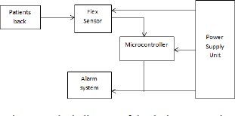

Figure 3.1: Block diagram of methodology of wearable posture monitoring device.

## : Theoretical background/ Design specification:

The resistive flex sensor (RFS) is a passive electronic component which works on the principle of bending the strip away from a reference. This bend results in change in the resistance of the device and hence, the output voltage fr om the device. Being a passive component, it does not require a power source to work [10]. The resistance therefore increases linearly as the bending angle increases. The equivalent circuit model of the sensor is as shown in

Figure 2.

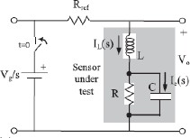

Figure 3.2: Equivalent circuit model for Resistive flex sensor [20].

Where 𝐼" is the inductor current; L is the inductance of the inductor; R is the resistance; C is the capacitance of the capacitor, 𝐼# is the capacitive current; 𝑉% 𝑠 is the supply voltage and 𝑉' is the output voltage. A RFS is often utilized in series with a fixed resistor to form a voltage divider circuit configuration. The flex sensor serves as the variable resistor as shown in Figure 3.

A fixed resistance of 10KΩ is adopted in this design, hence the express for output voltage (𝑉() [20, 21] is as indicated in Equation 1:



Where 𝑅45678 is the fixed resistance for this design; 𝑅4976 is the resistance of the flex sensor at that instance and 𝑉22 is the supply voltage.

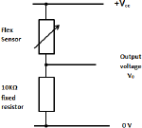

Figure 3.3: Flex sensor voltage divider configuration for this design.

## : Operational Algorithm:

Sequel to the sensor placemat as shown in Figure 5, the following steps [2] are required for the device operation:

Step I: Start — turn on the device.

Step II: Calibrate — after 10 sec of device use, a reference is created by the microcontroller.

Step III: Posture measurement /detection — microcontroller calculates the angle and threshold value.

Step IV: Compare the angle with the threshold, which one is bigger? — decide posture situation. Step V: Any flex sensor bending noticed? — Done by Microcontroller. If bent, slouching by the user is indicated, while otherwise indicates normal posture.

Step VI: Beep — Once the posture detected is poor (i.e. based on steps IV & V), the beep will be triggered by the buzzer controlled by the microcontroller for the posture adjustment by the user. Step VII: The posture detection information is sent to the mobile phone by using H05 Bluetooth module.

Step VIII: The Bluetooth module is a component that can send messages from sensor to the mobile application. Here using Bluetooth Serial Monitor application, I send the data to subject’s mobile phone in order to get messages from anywhere.

Step IX: In such a way my posture detection device is worked.

# Chapter 4

## Design procedure/ Experimental set-up and circuit diagram

* 1. **: Introduction:**

The device essentially consists of three sub-units including the sensor unit (i.e., flex sensor), control unit that house the microcontroller and power unit. The software used for designing the circuit diagram is Proteus Design Suite (Labcenter Electronics Ltd., North Yorkshire BD235AJ, England). The Arduino UNO (Arduino, Scarmagno, Italy) is the main part of the circuit of the system as all other components include resistor, buzzer, and others .

Table 1 presents the justification for material selection in this study

**Table 4.1: Material selection and justifications**

|  |  |  |  |
| --- | --- | --- | --- |
| S/N | Materials | Device Module | Justification |
| 1 | Flex sensor | Hardware | It is cheap and can be used to implement a safe monitoring system. |
| 2 | Arduino nano | Hardware / Software | Easy to program to read input and generate useful output. It is inexpensive and readily available |
| 3 | 160 k resistor | Hardware | It matches with the  resistance with the flex sensor. |
| 4 | Bluetooth module | Hardware | It can be easily interfaced with  Arduino uno. It is inexpressive and uses a low power radio frequency. It is interoperable, and it consumes very little energy. |

|  |  |  |  |
| --- | --- | --- | --- |
| 5 | Vibration motor/ buzzer | Hardware | Inexpensive, compact and easy way to realize a vibrating alarm system for the user. |
| 6 | Rechargeable battery | Hardware | It is cheap, flat, compact, rechargeable and available. |
| 7 | PCB board | Hardware | Provide electrical connection and mechanical support to the electrical components of the  circuit. |
| 8 | Wearable posture belt | Hardware | Can be attached vibrator and toil circuit for the purpose of wearing. |
| 9 | switch | hardware | To control the power of the battery. |
| 10 | Voltage regulator | hardware | To regulate the voltage in the Arduino. |

* + 1. **: Cost analysis:**

**Table 4.2: Cost analysis of Posture monitoring Device**

|  |  |  |
| --- | --- | --- |
| S No. | Component | Cost (taka) |
| 1 | Breadboard | 80 |
| 2 | Flex sensor | 2 k |
| 3 | Resistor | 05 |
| 4 | Arduino nano | 590 |
| 5 | Rechargeable battery | 160 |
| 6 | Voltage regulator | 15 |
| 7 | buzzer | 20 |
| 8 | PCB board | 400 |
| 9 | Bluetooth module | 470 |
| 10 | Wearable posture belt | 300 |
| 11 | LED light | 6 |

|  |  |  |
| --- | --- | --- |
| 12 | Wires and cables | 30 |
|  | Total cost = | 4076 taka |

## : Materials and method:

1. **Breadboard:** A breadboard is a commonly used tool in electronics and prototyping to create temporary circuits for testing and experimenting with electronic components. It provides a way to quickly and easily build and modify electronic circuits without the need for soldering. nd columns, and they allow you to insert electronic components and wires. The holes in each row are electrically connected horizontally, making it easy to create electrical connections between components. Breadboards usually have two sets of long rows on the sides, which are called terminal strips. These strips are used for power and ground connections, and they run the entire length of the board. They are often marked with a red line for positive voltage (VCC) and a blue or black line for ground (GND).

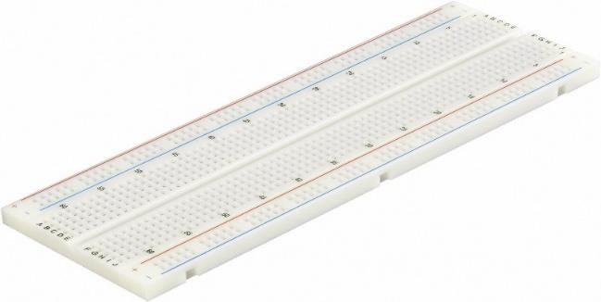

Figure 4.1: A picture of Breadboard.

1. **Flex sensor**: A flex sensor or bend sensor is a sensor that measures the amount of deflection or bending. Usually, the sensor is stuck to the surface, and resistance of sensor element is varied by bending the surface. Since the resistance is directly proportional to the amount of bend it is used as goniometer, and often called flexible potentiometer. Flex sensors are used in wide areas of research from computer interfaces, rehabilitation, security systems and even music interfaces. It is also famous among students and hobbyists.

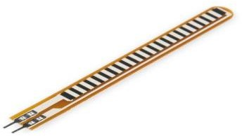

Figure 4.2: A picture of Flex sensor

**c. Arduino nano:** The Arduino Nano is an open-source breadboard-friendly microcontroller board based on the Microchip ATmega328P microcontroller (MCU) and developed by Arduino.cc and initially released in 2008. It offers the same connectivity and specs of the Arduino Uno board in a smaller form factor.[1] The Arduino Nano is equipped with 30 male I/O headers, in a DIP-30-like configuration, which can be programmed using the Arduino Software integrated development environment (IDE), which is common to all Arduino boards and running both online and offline. The board can be powered through a type-B mini-USB cable or from a 9 V battery

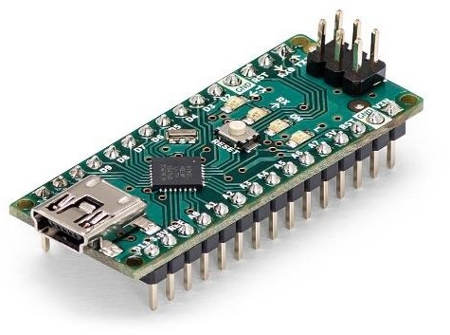

Figure 4.3: A picture of Arduino nano

1. **Bluetooth module**: Bluetooth module is a basic circuit set of chip which integrated Bluetooth functions and which can be used in wireless network transmission. Generally, the Bluetooth module can be divided into the following types: data transmission module, remote control module, etc. Bluetooth® technology uses the 2.4 GHz ISM spectrum band

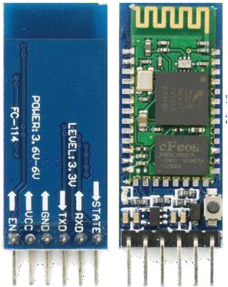(2400 to 2483.5 MHz), which enables a good balance between range and throughput. In addition, the 2.4 GHz band is available worldwide, making it a true standard for low-power wireless connectivity.

Figure 4.4: A picture of H05 Bluetooth module

1. **Buzzer/ Vibrator:** A buzzer or beeper is an audio signaling device, which may be mechanical, electromechanical, or piezoelectric (piezo for short). Typical uses of buzzers and beepers include alarm devices, timers, train and confirmation of user input such as a mouse click or keystroke.

Vibrator (mechanical), a class of devices which create mechanical vibrations for uses such as signaling annunciators, doorbells, or industrial uses such as compacting gravel, transporting materials, cleaning, etc.

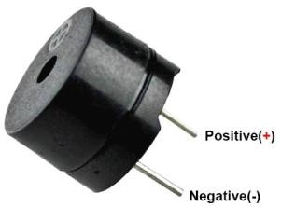

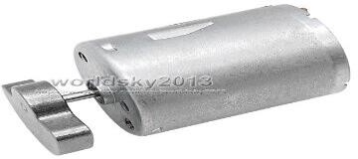

Figure 4.5: A picture of a buzzer and a vibrator.

1. **Resistor:** A resistor is an electrical component that limits or regulates the flow of electrical current in an electronic circuit. Resistors can also be used to provide a specific voltage for an active device such as a transistor. Here we have 160 k resistor.

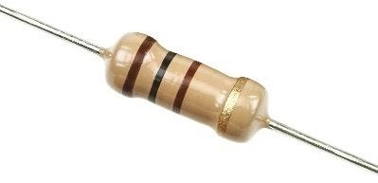

Figure 4.6: A picture of a resistor.

1. **LED light**: A light-emitting diode is a semiconductor device that emits light when current flows through it. Electrons in the semiconductor recombine with electron holes, releasing energy in the form of photons. The color of the light is determined by the energy required for electrons to cross the band gap of the semiconductor.

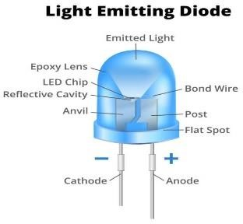

Figure 4.7: A picture of a LED light

1. **Rechargeable battery:** A rechargeable battery, also known as a secondary battery or accumulator, is a type of energy storage device that can be charged and discharged multiple times. Unlike single-use or disposable batteries, which are designed for one-time use and are discarded after their energy is depleted, rechargeable batteries are built to be recharged and reused, making them a more environmentally friendly and cost-effective choice.

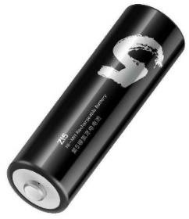

Figure 4.8: A picture of a rechargeable battery

1. **PCB board:** A PCB (Printed Circuit Board), often referred to simply as a "circuit board," is a fundamental component in the design and manufacturing of electronic devices and systems. It provides a physical platform for mounting and connecting various electronic components to create a functional electrical circuit. PCBs are typically made from a flat, non-conductive material, often fiberglass-reinforced epoxy or a similar substrate. The copper traces on a PCB create the electrical connections between components. PCBs can host a wide variety of electronic components. Surface-mount components are soldered directly onto the PCB's surface, while through-hole components have leads that pass through holes in the board and are soldered on the opposite side.

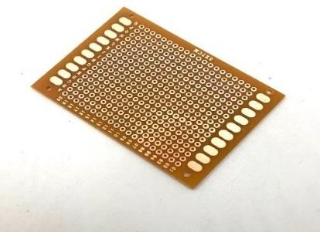

Figure 4.9: A picture of a PCB board.

1. **Voltage regulator:** A voltage regulator in used to maintain a constant voltage in the circuit. It may be used in a feed forward design or negative feedback. It may use electromechanical mechanism or electronic components. Depending on the design it may control AC or DC voltage.

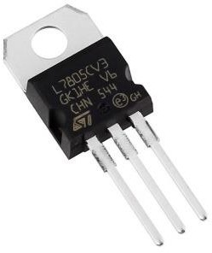

Figure 4.10: A picture of a voltage regulator.

1. **Wearable posture belt**: A wearable posture correction belt is a device designed to assist individuals in maintaining proper posture. These belts are typically worn around the upper back and shoulders and are designed to provide support and gentle reminders to encourage better posture. It is a belt that is used to attach the sensor and also the circuit. It is also a posture corrector.

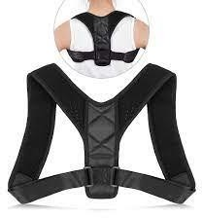

Figure 4.11: Posture correction belt.

## : Experimental setup:

The set up of my project is:

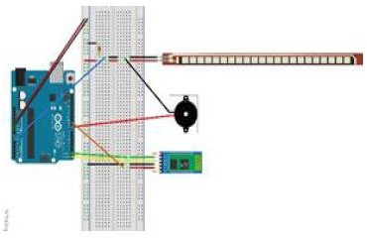

Figure 4.12: Total experimental setup of posture monitoring device.

## : Experimental procedure

The step wise design procedure or implementation techniques are given below:

1. For this project I need a bread board, a Arduino nano, a flex sensor, a 160k resistor, a buzzer or a vibrator module, a Bluetooth module, two LED light and some jumper wires for connection. We also need a laptop for uploading our Arduino code.
2. I connect now one end of the flex sensor to the 5 volt of the Arduino nano an another part to the bread board upper row.
3. Now I take another wire and connected with the Arduino’s ground and inserted the other hand into the lower row.
4. Next, I insert a 160 k resister to the breadboard. This 160k resistor will be in series with the flex sensor.
5. I connect 1 wire of the flex sensor over the resistor and connect the other wire to the 5 volt. This makes a voltage divider circuit.

25

1. Now I take another wire and connect between the resistor and the flex sensor and other end of the wire with the Arduino’s analog pin A2.
2. Now finally take another wire and connected with the remaining leg of the 160 k resistor and other end to the Arduino’s ground.
3. Two LED lights are connected with Arduino wire for signaling good or bad posture.
4. A buzzer is also attached to the circuit that sounds when the posture is incorrect.
5. Then I connect a H05 Bluetooth module in order to send data thorough mobile application.
6. A rechargeable battery is attached to power the circuit and make it wireless from the computer.
7. A voltage regulator is also attached with the circuit to regulate the voltage.
8. Now it’s the time for checking the if the circuit connection in the breadboard running correctly.
9. If run correctly then its time for soldering the circuit components permanently on the PCB board and make it wearable device by attaching with a posture correction belt.
10. At first for soldering, I design a PCB board. In which the components soldering is done.
11. One by one the components Arduino nano, flex sensor, resistor, LED, battery, voltage regulator are soldered.
12. Now the device is ready to attach the belt of posture correction.
13. After that by using a app named Bluetooth Serial Monitor I send the data of sensor posture position to the mobile phone app.
14. In such a way we can get the information of our posture through our mobile phone and can maintain correct posture.
15. After attaching the sensor, battery portion and the main circuit portion to the posture correcting belt, I have completed the whole project.

# Chapter 5

## Implementation (Step by Steps with pictorial view)

* 1. **: Breadboard implementation**

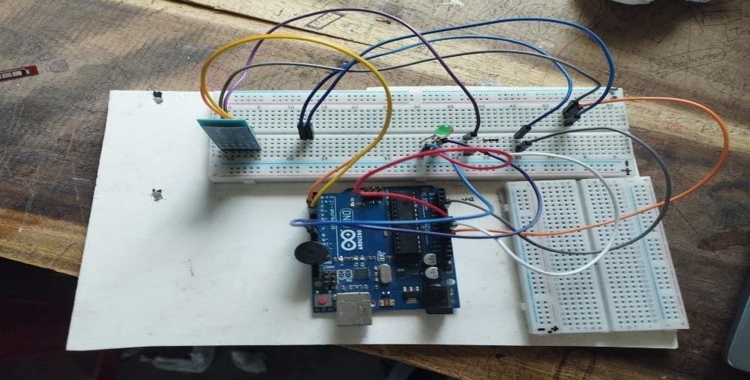

Figure 5.1: Here Arduino, 160 k resistor and LED are attached. Also a Bluetooth module is attached to send the data into mobile application.

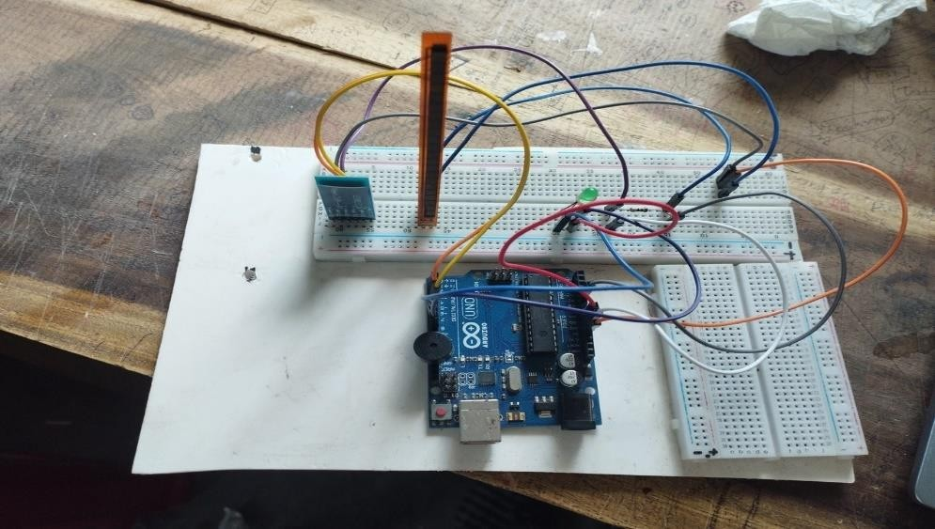

Figure 5.2: Here the main flex sensor is attached. And the circuit is completed.

## : PCB connection:

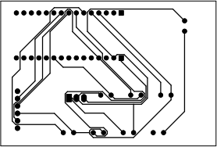

Figure 5.3: The main designed circuit of my PCB board

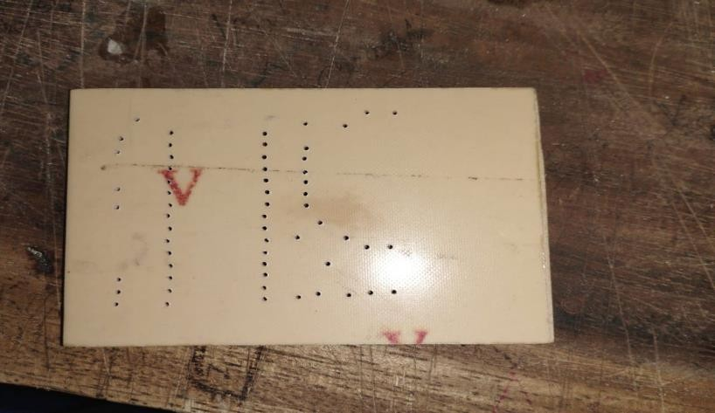

Figure 5.4: Here the back portion of my PCB board after printing.

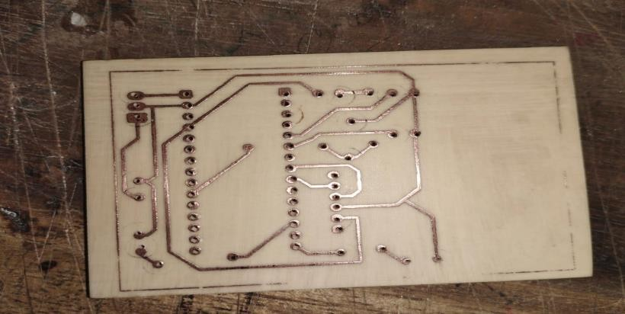

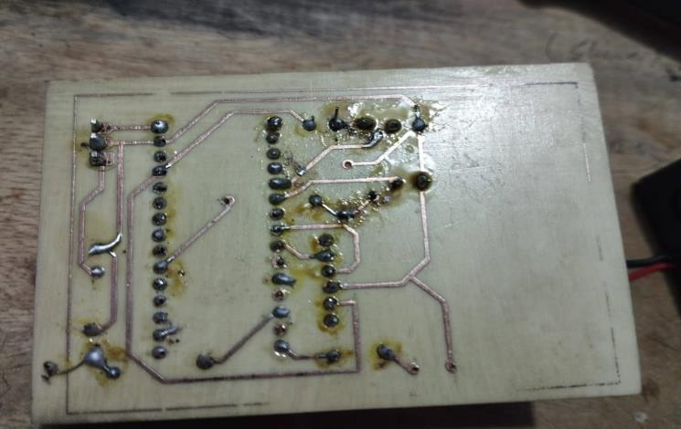

Figure5.6: After completing soldering it is the picture of back portion of my PCB board.

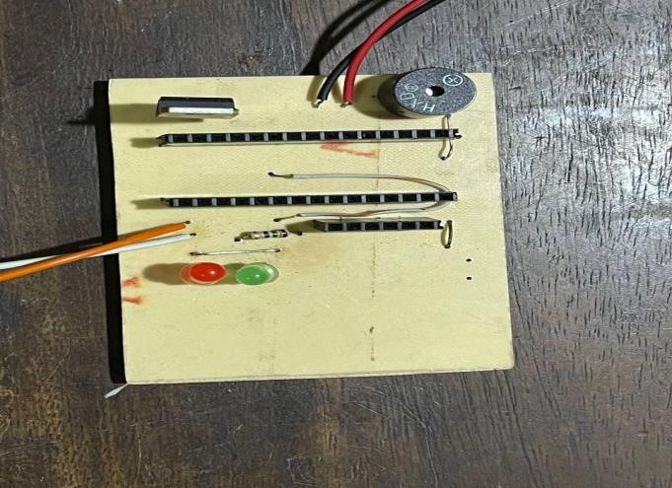

Figure 5.7: Attaching LEDs, resistor and buzzer on my PCB board

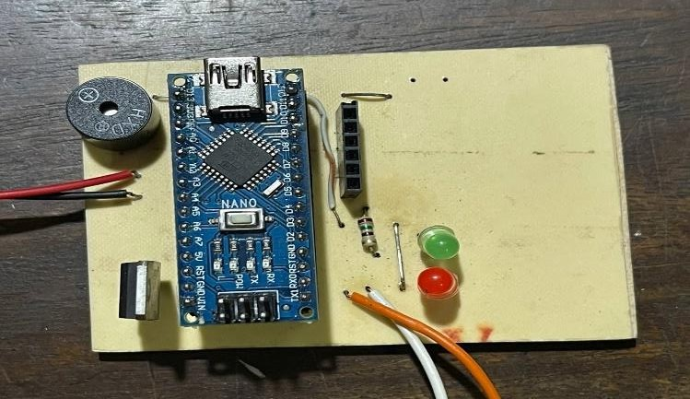

Figure 5.8: After connecting my Arduino Nano on my PCB board

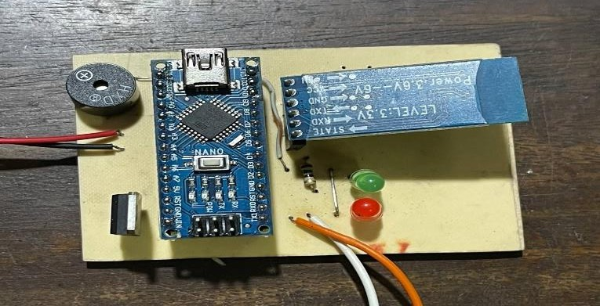

Figure 5.9: After connecting Bluetooth module on my PCB board

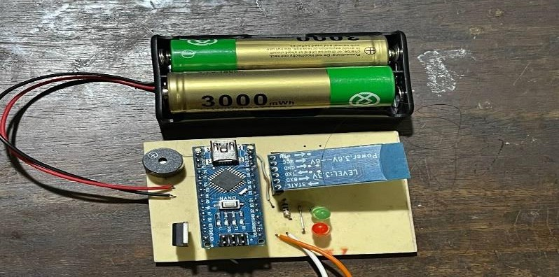

Figure 5.10: After connecting two rechargeable batteries on my PCB board

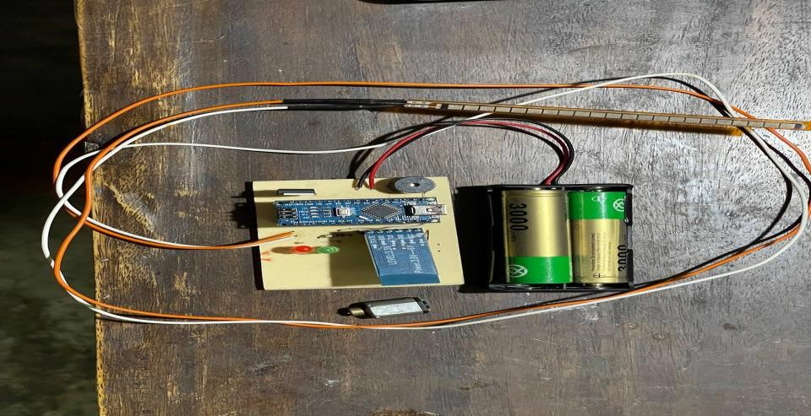

Figure 5.11: After attaching flex sensor to my PCB board and here is a also a vibration motor.

### : Total posture monitoring device including IOT:

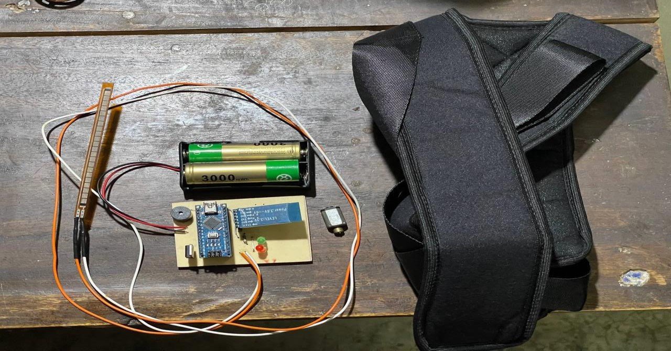

Figure 5.12: Here is an attachable posture correction belt for attaching flex sensor.

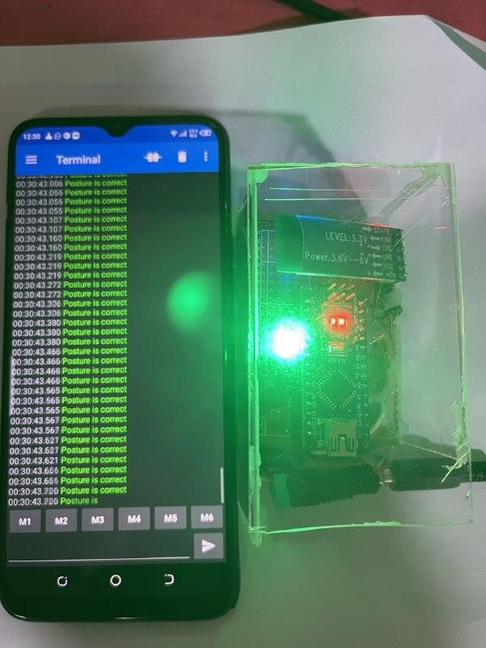

Figure 5.13: Iot based posture monitoring device

* 1. **: Results**

# Chapter 6

## Result and Discussion

* + 1. **: Threshold value calculation:**

For my device the Threshold value is 120. If a person bends more than 12 degrees from vertical axis than the device detects the posture is incorrect.

Here is a chart of 6 persons. They wear the device and try to monitor their posture and threshold value.

### Table 6.1 : Threshold values and at which threshold value for each person the buzzer is on.

|  |  |  |  |  |
| --- | --- | --- | --- | --- |
| S/N | Given Threshold value for the device (in  degree) | Their Threshold value( in degree) | Buzzer is on for 120 | Buzzer is on for another threshold value |
| Person 1 | 12 | 14 | no | yes |
| Person 2 | 12 | 12 | yes | no |
| Person 3 | 12 | 14 | no | yes |
| Person 4 | 12 | 16 | no | yes |
| Person 5 | 12 | 12 | yes | no |
| Person 6 | 12 | 12 | yes | no |

Here we can see that the threshold value is sometimes different from the set threshold value. That means the individuals posture is correct at different value. Here for setting up the device we need to set a value which is 12 degrees from the vertical 180 degrees. But it is not always correct for everyone. Someone has more than 120 and will be smaller than that if we check the device for more subjects.

## : Sensitivity Calculation:

Five separate trials were performed for each 5 participants with some degrees reduction (i.e., starting from 180-degree as the reference point at upright stance/sitting to 145-degree) in the hip flexion angle at sagittal plane when the volunteers were in upright/normal anatomical position. The results of the tests carried out on the volunteers to determine the functionality and sensitivity of the device showed that when the participants were in the upright postural position (180), which was considered normal postural position, where there was no alarm. However, when the participants were at other five different hip flexion positions (i.e., 170, 165, 160, 150, 145) there were alerts in each case demonstrating that the device sensed that the participants were slouching indicating bad posture which may lead to bad musculoskeletal conditions.

To determine the device’s sensitivity, we employed the standard formula and reported the results in Table 6.2. Based on the following formulae (Equation 2) was applied.

**Sensitivity =** 𝑻𝑷

𝑻𝑷+𝑭𝑵

### X 100 (1)

Where TB is true positive i.e. when the device correctly indicated that the participant was slouching and FN is when false negative i.e. when the device wrongly indicated that the participant was not slouching.

Here are some trials for 5 subjects at some different position to determine the sensitivity of my posture monitoring device.

**For subject 1:** Number of trials = 07 TP = 04

FN = 02

FP = 01

Sensitivity = 4/6 *100

= 66.66%

### For subject 2:

Number of trials = 06 TP = 03

FN = 02

FP = 01

Sensitivity = 3/5 *100 = 60%

### For subject 3:

Number of trials = 10 TP= 06

FN = 02

FP = 02

Sensitivity = 6/8 *100 = 75 %

### For subject 4:

Number of trials = 08 TP = 05

FN = 03

FP = 00

Sensitivity = 5/6 * 100 = 62.5%

### For subject 5:

Number of trials = 06 TP = 04

FN = 01

FP = 01

Sensitivity = 4/5 *100 = 80%

Abbreviations: TP- True Positive; FN- Force Negative; FP- Force Positive

### Table 6.2 : Determine the sensitivity of my Posture Monitoring Device

|  |  |  |  |  |  |
| --- | --- | --- | --- | --- | --- |
| Subject No. | Number of trials | TP | FN | FP | Sensitivity (%) |
| 01 | 07 | 04 | 02 | 01 | 66.66 |
| 02 | 06 | 03 | 02 | 01 | 60 |
| 03 | 10 | 06 | 02 | 02 | 75 |
| 04 | 08 | 05 | 03 | 00 | 62.5 |
| 05 | 06 | 04 | 01 | 01 | 80 |

The average sensitivity is (66.66+60+75+62.5+80+70) / 5 = 68.83%

Considering all the participants’ results, the device had an average sensitivity value of 68.83% which may be adjudged good and encouraging results for further clinical use.

## : Discussions:

From those above calculation, we can say that the threshold value for different subject is different sometimes. The buzzer is ringing at standard 12 degree bending but sometimes at 14 degree and more than that. Actually we need to set a standard threshold value for my device to run. Secondly for sensitivity calculation we take 5 subjects. We here take more than one trials for each person. From different trials we get true positive value which means that the device correctly detecting the poor posture. We can also detect the false negative value that means it is not correctly detecting the poor posture. From these values we can calculate the sensitivity the device. Sensitivity means how much the device can determine the posture position correctly. From those results the average sensitivity of the device is 68.83%.

it means the device is average good. It requires more modification for clinical use.

There are some limitations of this project. Like belt design. If belt is not design universally then the device will give random value. So correct and comfortable belt should be designed. Here in my project this affects my device. Due to some limitations my belt is not properly designed. So sometimes it can no detect poor posture correctly. Moreover flex sensor sometimes isn’t work. So proper sensor preparation is required to increase it’s sensitivity.

# Chapter 7

## Conclusion and Future Work

* 1. **Conclusion:**

This wearable posture monitoring device is very useful for our day-to-day life. As it is IOT based so we can store the data in a cloud storage and use it for further purposes. There are so many advantages of this device such as, the device continuously monitors the person’s posture in real- time. It also provides immediate feedback to the user when posture is not correct. Moreover it prevents musculoskeletal disorders and promotes active sitting. By giving alert this device can aware the person about his/her posture position, reminding them to correct posture. We can also integrate this device with some smart devices to improve it’s function. Sensor information mobile application helps user to share the data with medical professionals. It also a nice device for office environment for the employees for correcting their posture position and as a result they can maintain a healthy body and reduce the risk of work related back injuries. There are some other advantages of this device. Used in rehabilitation settings to monitor and guide individuals recovering from injuries. Supports physical therapy programs by providing real-time feedback during exercises aimed at improving posture and monitoring. Data collected from this device may be valuable for researchers for studying posture related issues and solutions. It also enables the collection of long-term data on posture habits, contributing a better understanding of posture related heath challenges.

## : Future work:

In order to improve the device, make it more comfortable and user friendly there will be my future works on my project:

* + 1. It will be beneficial to Develop and integrate more advanced and accurate flex sensors to improve the precision of posture detection.
    2. It would be a great step if I will combine flex sensors with other types of sensors (accelerometers, gyroscopes, etc.) for a comprehensive and multi-dimensional analysis of posture.
    3. I try to Implement machine learning algorithms to analyze posture data and provide more intelligent and personalized feedback to users.
    4. I will give some focus on developing systems that can create individual user profiles, taking into account factors such as body type, age, and health conditions for more personalized feedback and recommendations.
    5. I will work on making the sensors and the overall device more compact and discreet for increased wearability.
    6. I will try use flexible and comfortable materials in the design to ensure prolonged use without causing discomfort or hindering natural movement.
    7. I will try to improve integration with smartphones, smartwatches, or other smart devices to provide seamless user experiences and enable additional features.
    8. It would be efficient step to provide educational content within the device or accompanying app to help users understand the importance of good posture and the impact on overall health.
    9. I will try to generate regular progress reports and insights to keep users informed about their posture improvement journey.

## References:

1. S. L. James, D. Abate, K. H. Abate *et al.*, “Global, regional, and national incidence, prevalence, and years lived with disability for 354 diseases and injuries for 195 countries and territories, 1990–2017: a systematic analysis for the Global Burden of Disease Study 2017,” *The Lancet,* vol. 392, no. 10159, pp. 1789-1858, 2018/11/10/, 2018.
2. A. M. Briggs, A. D. Woolf, K. Dreinhöfer *et al.*, “Reducing the global burden of musculoskeletal conditions,”

*Bulletin of the World Health Organization,* vol. 96, no. 5, pp. 366-368, 2018.

1. A. D. Woolf, J. Erwin, and L. March, “The need to address the burden of musculoskeletal conditions,” *Best Practice & Research Clinical Rheumatology,* vol. 26, no. 2, pp. 183-224, 2012/04/01/, 2012.
2. A. Reeve, and A. Dilley, “Effects of posture on the thickness of transversus abdominis in pain-free subjects,”

*Manual Therapy,* vol. 14, no. 6, pp. 679- 684, 2009/12/01/, 2009.

1. C. Lynders, “The Critical Role of Development of the Transversus Abdominis in the Prevention and Treatment of Low Back Pain,” *HSS Journal®,* vol. 15, no. 3, pp. 214-220, 2019.

37

1. S. Ye, Q. Jing, C. Wei *et al.*, “Risk factors of nonspecific neck pain and low back pain in computer using office workers in China: a cross-sectional study,” *BMJ Open,* vol. 7, no. 4, pp. e014914, Apr 11, 2017.
2. I. Nastasia, M.-F. Coutu, R. Rives *et al.*, “Role and Responsibilities of Supervisors in the Sustainable Return to Work of Workers Following a Work- Related Musculoskeletal Disorder,” *Journal of Occupational Rehabilitation,* vol. 31, no. 1, pp. 107- 118, 2021/03/01, 2021.
3. L. Bey, and M. T. Hamilton, “Suppression of skeletal muscle lipoprotein lipase activity during physical inactivity: a molecular reason to maintain daily low intensity activity,” *The Journal of Physiology,* vol. 551, no. 2, pp. 673-682, 2003.
4. C. R. Freed, and B. K. Yamamoto, “Regional brain dopamine metabolism: a marker for the speed, direction, and posture of moving animals,” *Science,* vol. 229, no. 4708, pp. 62, 1985.
5. M.-L. Nault, P. Allard, S. Hinse *et al.*, “Relations Between Standing Stability and Body Posture Parameters in Adolescent Idiopathic Scoliosis,”*Spine,* vol. 27, no. 17, pp. 1911-1917, 2002.
6. J. R. Engsberg, L. G. Lenke, M. L. Uhrich *et al.*, “Prospective Comparison of Gait and Trunk Range of Motion in Adolescents With Idiopathic Thoracic Scoliosis Undergoing Anterior or Posterior Spinal Fusion,” *Spine,* vol. 28, no. 17, pp. 1993-2000, 2003.
7. H. Hsiao, and W. Monroe Keyserling, “A threedimensional ultrasonic system for posture measurement,”

*Ergonomics,* vol. 33, no. 9, pp. 1089- 1114, 1990/09/01, 1990.

1. L. E. Dunne, P. Walsh, S. Hermann *et al.*, “Wearable Monitoring of Seated Spinal Posture,” *IEEE Transactions on Biomedical Circuits and Systems,* vol. 2, no. 2, pp. 97-105, 2008.
2. M. Gopinath, and A. Kirubha, “Real Time Monitoring of Posture to Improve Ergonomics,” *Journal of Biomedical Engineering and Medical Imaging,* vol. 2, no. 2, pp. 22-25, 05/02, 2015.
3. N. K. M. Yoong, J. Perring, and R. J. Mobbs, “Commercial Postural Devices: A Review,” *Sensors,* vol. 19, no. 23, pp. 5128, 2019.
4. G. Johnson, N. Bogduk, A. Nowitzke *et al.*, “Anatomy and actions of the trapezius muscle,” *Clinical Biomechanics,* vol. 9, no. 1, pp. 44-50, 1994/01/01/, 1994.
5. J. Ourieff, B. Scheckel, and A. Agarwal, "Anatomy, Back, Trapezius," *StatPearls [Internet]*, Treasure Island (FL): StatPearls Publishing, 2020.
6. T. Luger, R. Seibt, T. J. Cobb *et al.*, “Influence of a passive lower-limb exoskeleton during simulated industrial work tasks on physical load, upper body posture, postural control and discomfort,” *Applied Ergonomics,* vol. 80, pp. 152-160, 2019/10/01/, 2019.
7. Y. K. Ahmed, A. R. Zubair, S. Sani *et al.*, “Design and Construction of a Portable Electronic Sleep

Inducer for Low Resource Settings,” *FUOYE Journal of Engineering and Technology,* vol. 5, no. 2, pp. 84-88, 2020.

1. G. Saggio, F. Riillo, L. Sbernini *et al.*, “Resistive flex sensors: a survey,” *Smart Materials and Structures,* vol. 25, no. 1, pp. 013001, 2015/12/02, 2015.

39

40